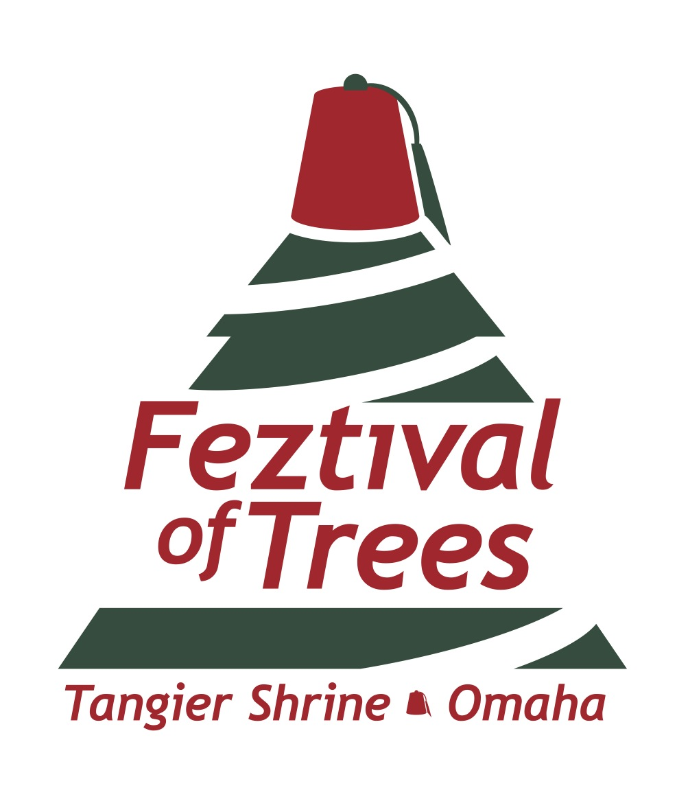
2023 Tree Sponsor Rules and Guidelines
Nov 18-25, 2023

The Feztival of Trees fundraiser is an excellent opportunity for businesses to show their philanthropic support while receiving public recognition for their contribution. This type of event has been hosted by other Shrine organizations around the United States for several years. The Tangier Shrine sponsored its inaugural Feztival of Trees event in 2017.

Based on the success of our most recent annual event and other similar events, we expect between 20,000 and 30,000 people will view the trees.

The deadline for Tree Sponsor applications is: Oct. 14, 2023
Limited Space Available

Questions? Contact the Tangier Office at (402) 392-0404 or Tricia (402)960-9385.
About the Feztival of Trees
Business sponsors will be recognized with signage at the event, on the event promotion materials (including social media, website, and emails), in the Tangier Shrine Hot Sands newsletter, and in the media. Businesses are also encouraged to promote your involvement through your social media channels, advertising, and internal and external emails. You are also welcome to distribute promotional materials and/or conduct sampling or demos for your company within your display area, subject to approval.

You will select a theme for your tree. The theme will be displayed under your company name or logo and on the raffle box.

Your tree theme is limited only to your imagination. Previously, tree themes included the Huskers, trains, dinosaurs, chicken coops, and clowns. In another Shrine’s Feztival of Trees event, a car dealership includes a used car as a prize every year — the car is displayed prominently in the parking lot with the company’s name on it!

Almost any type of company can be a sponsor: Retailers, grocery stores, car dealers, tire stores, sporting goods stores, barber shops, lumber yards, or restaurants.

The public is invited to view the trees during the display period: Saturday, Nov. 18 through Saturday, Nov. 25. (Dates are subject to change.) Admission is $2 per person for those age 13 and above. (No charge for children under 12 when accompanied by an adult.)

Hours of operation:
Saturday, Nov. 18 9 a.m. to 9 p.m.
Sunday, Nov. 19 Noon to 5 p.m.
Monday, Nov. 20 10 a.m. to 9 p.m.
Tuesday, Nov. 21 10 a.m. to 9 p.m.
Wednesday, Nov. 22 10 a.m. to 9 p.m.
Thursday, Nov. 23 CLOSED for Thanksgiving
Friday, Nov. 24 9 a.m. to 9 p.m.
Saturday, Nov. 25 9 a.m. to 5 p.m.

Refreshments will be available for purchase at the event. Santa Claus will also be available during selected days and times.

How Tree Winners are Selected
Attendees can purchase raffle tickets for $1 per ticket. Raffle tickets are deposited in the container affiliated with the tree display. There is no limit to the number of raffle tickets that can be purchased. Businesses may purchase raffle tickets for their own tree.

One ticket will be drawn as a winner for each tree. That ticket will win the entire tree and the gifts associated with that tree.

Winners will be contacted by phone immediately following the raffle ticket drawing. The list of winners will also be posted on the Tangier Shrine website. Trees must be picked up by the winners between 9:00 a.m. and 12:00 p.m. on Sunday, Nov. 26 (or alternate arrangements must be made).

Tree Sponsor Rules & Guidelines

Tree Requirements
The value of the tree and prizes are required to be valued at a minimum of $500. Most trees have been valued between $1,000 and $3,500. The higher the value, the more attention your tree will likely get!

Tree spaces are approximately 5 x 7 feet. The tree and prizes must fit in the designated area. All trees must be artificial (no real trees), no real vegetation. If trees are lit (recommended), the lights must be LED lighting, and the tree sponsor must supply a new power cord (25 foot) that meets electrical code.

Trees may be any size or any style, up to a maximum height of 8 feet. Keep in mind that smaller trees need to be elevated to be visible.

The tree sponsor must supply all setup accessories — including, but not limited to: wire, tape, decorations, hangers, wire ties, etc. Trees must be properly secured and be free-standing. No screws, nails, etc. Tree skirting is recommended.

Prize Requirements
If any item that is displayed is not included with the tree, it must be clearly marked as such. Any item not marked will be considered part of the tree package and will be given to the winner.

Do not attach real money (cash) to the trees. You can use a card, play money, or paper printed to look like money. Please provide any cash prizes in an envelope marked with the tree number and sponsor name. This envelope will be placed in the Tangier Shrine safe and given to the winner when they pick up their tree. All other items that are not displayed with the tree — but are included in the prize package — must be provided to the Tangier Shrine by 4 p.m. on Wednesday, Nov. 15. These items will be secured in a locked room until they are claimed by the winners.

Setup Dates
Trees can be set up:
Sun, Nov 12, 12:00 P.M. to 4:00 P.M.
Mon, Nov 13, 9:00 A.M. to 7:00 P.M.
Tue, Nov 14, 9:00 A.M. to 7:00 P.M.
All trees must be set up by 7:00 P.M on Tuesday, Nov. 14 or business forfeits its ability to participate. No raffle prize will be awarded on behalf of the business in the event no tree is displayed. However, the business will still be responsible for providing a $500 payment to the Tangier Shrine.

A soft opening will be held on Friday, Nov. 17 from 7 p.m. to 9 p.m. for the Sponsors and their families and their employees.

Tree Assignments
Tree Sponsorship will be available up to 60 Spaces.
Tangier reserves the right to move trees as needed.

Limitations of Liability
Tangier Shrine is not responsible for loss or damage to any trees, prizes, or displays.

2023 Tree Sponsor Commitment Form

Please Print

Business/Organization

Contact Name

Address

City State Zip

Phone Number

Email

Referred by/How did you hear about this event?

TREE THEME

Do you have a Facebook page? Would you like us to tag you on social media?

If so, what is the name/URL:

Do you have a Twitter profile? Would you like us to tag you on social media?

If so, what is the name/URL: @

Please read and keep the attached Tree Sponsor Rules & Guidelines form.

Signature

Tree sponsors are accepted on a first-come, first-committed basis until all available spaces have been reserved. Note: Your submission of this form is a commitment to participate. If no tree is displayed by the deadline, a $500 payment must be sent to Tangier.

FOR OFFICE USE ONLY
Date Received in Office Date Postmarked
Assigned Tree Number
Confirmed with Sponsor (Date) (By)
Noble Contact Information
Notes

